Camila Rocha

May 3, 2020

CIM 111

Professor Jose Guzman

**Marketing Plan**

**Facebook**

**Marketing objective:** Brand Awareness

**Consideration objective:** Traffic (the more people who see my brand, the more its possible that my name will become top of mind for recruiters)

**Conversion objectives**: There is no conversion necessarily needed because I am not selling anything. A conversion in this case could be the moment recruiters contact me via the information provided on my resume.

**Dynamic Ads:** I would maybe make use of FB’s dynamic ads since they can target people by matching their interests with a product on the website that is being promoted. Although I do not have products, I have design campaigns related to specific products such as Vans. If someone were looking up Vans, they would see my work. If someone was looking up techno or DJs, Peggy Gou might show up.

**Target Audience:** I would use FB’s core audience and choose locations that are relevant to where I would like to work. These would be advertising hubs like New York and Chicago. I would include LA and Miami as well. Demographics would range in age and gender but would be more specific in terms of education and job title. Here I would put emphasis on people with at least a bachelors degree, emphasize the universities that are known for their advertising programs, and people who work in marketing or advertising.

**Automatic placement:** I would choose this option so that Facebook can make the most of my budget by placing ads where they are most successful instead of areas where they rarely reach my target. This includes Facebook Stories, Facebook Feed, and Instagram Explore Feed.

**Ad manager**: I would track which ads are performing the best, deduce what factors are causing that success and apply that to my other ads. For example, if I see that ads with vibrant colors are doing better than monochromatic ones, I’ll know that vibrant colors are garnering more attention. I would also look at my cost per results to make sure that my costs are low in comparison to the success of my ads. Eventually I would choose the top KPIs to track for my website.

**Google**

**Overall goal:** Drive traffic to website

**Google Ads:** I will include a short message about the best and most important parts of my portfolio and what I offer as a creative. I will use different headlines for different ads and then use analytics to see which words work best. I will also include a call to action such as a “call me” function or “contact me” so that recruiters, or anyone who is interested, can reach out to me easily. I will also choose to advertise **globally** as my goals are to reach people beyond the local area of Miami.

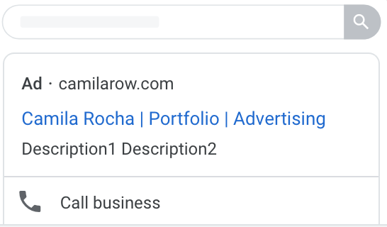

**Google Analytics:** I will combine my Google Ads account with the Google Analytics account so that I can gain further insights into the performance of my Google Ads. This will also help me differentiate which words or headlines are working best for my Google Ads.

I will track how many clicks my ads get and how many visitors reach my website. I will also track what hours of the day people are engaging with my content and how much time is spent on my page. All of these data points will help me create better ads, budget more efficiently, and target more effectively.

Google Analytics can also tell me which keywords are used to find my website or content that is related. I will look at this data to help me find what words are relevant to my website and use those words in my Google Ads.

**SEO**

My HTML has been written so that my “title” and “headings” are relevant to my website, which in this case my portfolio. Since search engines will look at this when developing search results, it is important that they are accurate and match the type of search results I want for my website. My title includes “Portfolio – Camila Rocha” so that if any recruiter wants to look for my portfolio specifically, he or she will be able to do so. From past experience, I have also noticed that if a business is spewing out a lot of content, it is more likely to harness more engagements and therefore become a top search result. For this reason, I will eventually create an Instagram account and post content relating to freelance work and designs that link to my website. The more active I am, the more people are likely to engage with my website and consequently the more likely it is that my website will be a top search result.